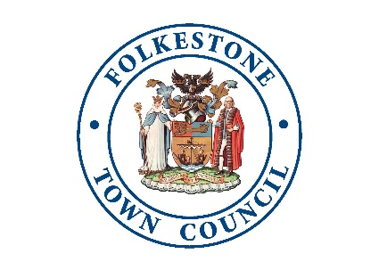

FOLKESTONE TOWN COUNCIL

Policy Guidelines for the Approval and

Distribution of Town Grants

1. The Town Council is prepared to consider applications for financial assistance of up to £2,500 from:

(a) clubs and societies;
- voluntary bodies and associations;
(c) non-profit making organisations;
(d) charitable bodies
(e) individual members of the community

Applicants should complete the correct form dependent on the amount of the grant; under £1000 or £1000 and over.

2. In order to qualify for assistance, applications must demonstrate a direct benefit to the Folkestone Town area, or any part of it, or to all or some of its residents. In addition, the direct benefit accruing must be commensurate with the expenditure to be incurred. Local groups that are affiliated to regional or national organisations will qualify provided the local group is required to function substantially as an independent financial unit.

3. All applications for financial assistance must be made using the Council’s Town Grant application form and must be accompanied by the appropriate supporting information requested in the form. Incomplete applications will not be considered and will be returned.

4. Applications may be submitted at any time and will normally be considered at the next meeting of the Town Council, providing the application is received at the Town Council Offices, The Town Hall, 1-2 Guildhall Street, Folkestone, CT20 1DY, or via email to: liz.timmins@folkestone-tc.gov.uk at least 14 working days before the relevant meeting.

5. Applicants should only apply for one grant per project and may apply for up to three projects during a financial year (1 April to 31 March). The primary intention of the Town Council’s grant scheme is to support new events and projects in the town.

6. In the case of a successful application, the financial assistance should be taken up during the financial year (1 April to 31 March) in which the Council approves the application. Applicants will be required to complete a feedback form confirming that the funding has been used for the purpose requested. Failure to return this form is likely to preclude the applicant from being considered for a Town Council grant in the future.
7. The Town Council might refer applicants to other bodies as appropriate.

8. Where £1000 or more is requested, a representative maybe invited to attend the relevant meeting and answer questions put to them by members.

9. Grants will not be paid where the service is normally provided directly by a principal Council, the Health Authority or Central Government.

10. Private concerns operated as a business to make a profit will not normally be grant aided, unless there is demonstrable benefit for local employment.

- Grants will not be made to registered charities seeking to add to their capital investments.

- Local Groups whose total fund raising is sent to their central headquarters for redistribution will not be assisted.

- Grants will not be given for specifically religious or party political purposes.

- Grants will not be given to profit making organisations with unallocated reserves.

- Grants will not be paid if the application is submitted after the project or event has
taken place.

- Any offer of funding is discretionary, the Council’s decision is final and there is no right of appeal.

Enquiries to:

Liz Timmins
Folkestone Town Council
The Town Hall
1-2 Guildhall Street
Folkestone
CT20 1DY

Tel: (01303) 257946
Email: liz.timmins@folkestone-tc.gov.uk

