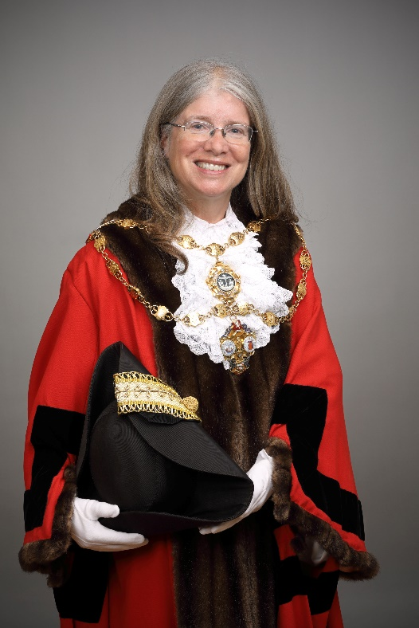
Councillor Belinda Walker
The Worshipful Town Mayor of Folkestone – 2023-24

Belinda was born into an army family and lived in Malaysia, and in West Berlin during the Cold War, as a child before returning to the UK. Belinda’s mum was from Germany but she grew up at a time when bilingualism was discouraged so her German is still only very basic.
She spent her teenage and younger working life in south London, working for local newspapers, New Musical Express, the Poetry Society and the CPRE (at the time the Council for the Protection of Rural England) At the age of thirty she gained entry to University College London to train as Speech and Language Therapist. Once qualified, she travelled to Folkestone for a job interview at the Stroke Unit which was based at the Royal Victoria Hospital. It was her first time in Folkestone, and she fell in love with the town so when she was offered the job she jumped at the chance and moved down in October 1995. Belinda says, “Being Mayor is an incredible honour and I never would have dreamt that I would end up in that role as I walked along the Leas the day of my job interview.”
Belinda continued to work at the Stroke Unit when it moved to the William Harvey, but Folkestone pulled her back and she took up a job with a community-based team covering Folkestone Hythe and Romney Marsh and for 26 years she worked with patients with stroke and a variety of other neurological disorders such as Parkinson’s Disease and Motor Neurone Disease. She retired last year and took up some voluntary roles in addition to her council work. Belinda works in the homeless drop-in, teaches English to refugees, and volunteers at the Community Fridge. She was also delighted to have been elected to the District Council in May 2023. Belinda also volunteers as a lay visitor with the Motor Neurone Disease Association and visits people with that condition in the local area. She is a member of one of the local churches and recently took up a post of a school governor which she is really enjoying.
Her sister lives in south-west Scotland so she is frequent visitor up to her village which has become like a second home to her.
Belinda enjoys countryside walks, reading and writing short stories. She loves being by the sea and, controversially, is fond of seagulls! Belinda is aware of how fortunate she is to live in a beautiful part of the world in a town with a strong community spirit. There have been many changes in Folkestone over the years but the sense of being community together appears to be stronger than ever.

